**Max Flow Extension Summary**

**Circulation with Demands**: Directed graph G = (V, E), with edge capacity c(e), and node supply or demand d(v), demand if d(v) > 0, supply if d(v) < 0.

**Two Properties:**

Capacity Property: for each flow value 0 <= f(e) <= c(e)

Conservation property: sum(flow into v) – sum(flow out of v) = d(v)

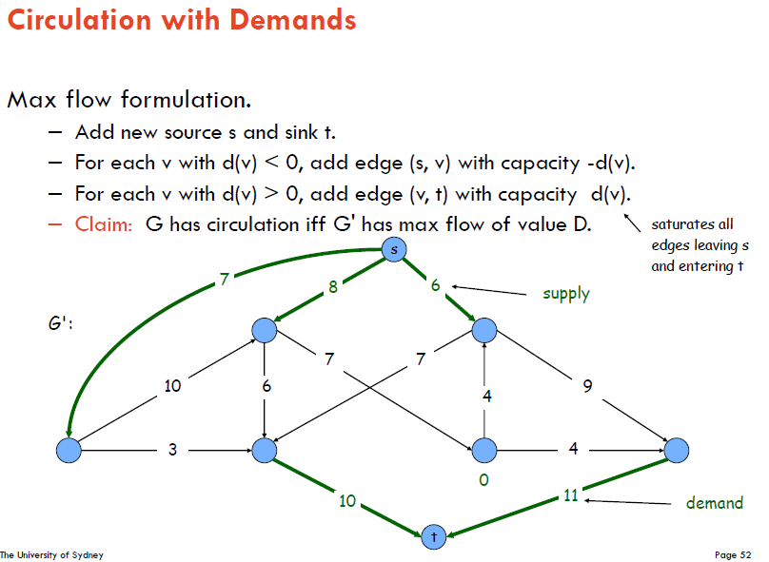

**Theorem:** There exists a circulaton in G if and only if there exists a circulation in G’

**Integrality Theorem**: If all capacities and demands are integers, and there exists a circulation, then there exists one circulation that is interger-valued.

**Characterization**: Given (V, E, c, d), there is a feasible circulation with demand dv if and only if for all cuts (A, B), sum(dv of v in B) <= cap(A, B).